Generating Passive Income For Young Adults Through Value Investing Machine Learning
Ava Patel, Michelle Ihetu, & Ardoine Docteur
CSCE 585
Prof. P. Jamshidi
November 8, 2025
Abstract
The objective of this work is to generate a source of passive income for young adults through a lightweight machine learning algorithm that specializes in financial stock pattern recognition. The model utilizes a value index investing framework to target undervalued stocks to yield the highest financial returns. Value index investing is the chosen investment strategy since it provides investors stable investment returns at the lowest risk. There are four key indicators to assess the financial wellness of a company including valuation and risk profile:Price to Earnings (P/E), Price to Booking (P/B), Debt to Equity(D/E) and Free Cash Flow (FCF). It is hypothesized that a financial portfolio that utilizes machine learning techniques combined with value indexing metrics will outperform the traditional market strategies S&P 500 and the Russell 1000 Index because of the tensorflow keras model ability to draw complex relationships between nodes of data. Likewise, the team will be observing the effects of quantization level on model performance and accuracy.
The experimentation is divided into three sections - the effects of parameters, activation layers and quantization levels have on model performance. It was discovered that the model achieves its optimal performance of 98% when it is given a batch size of 128, dense layer of 256 at a dropout rate of 30% regardless of quantization levels.

Introduction
In the onset of a declining job market and tumultuous economy, many young adults do not have a stable source of income to rely upon for long term life goals; thus people begin to seek forms of passive income. A recent survey by Stash declares that over 90% of young adults express interest in learning how to invest but lack the knowledge to do so. Most people do not take the initiative to learn to invest because of the perception that it is ‘complicated’ and the fear of losing money because of the volatile nature of the market. To increase financial literacy among young adults and encourage people to engage in the stock market, the team has created a machine learning model that is able to receive user input on paper money value, desired return value and when they would like to receive it. The machine learning model will conduct a financial analysis of S&P 500 stock by accessing an API of a publicly available mutual fund index. The goal is to ultimately target a stock at its lowest value and sell at its highest generating revenue for the client.
For second quarter model development, the team utilized a Tensorflow based sequential model to act as our machine learning model. The team chose a sequential based operation since the model is being fed time series data so therefore the model can design short and long term memory networks. This supports our objective to design a financial modeling system that can make future predictions based on historical financial data.

Related Works
An attractive quality of the stock market is its volatility - high risks yield high rewards yet it is the very thing that deters many prospective investors. Investors yearn for predictability, reassurance that their funds will not go to waste so they seek machine learning tools to increase confidence in their financial forecasts. Fortunately, there are many established bodies of work that utilize value investing methods to increase investor confidence.
Machine learning models specialize in making predictions based on historical data. One team explored a quantitative investment strategy that tracks stock volatility through a combination of time series and machine learning models. This approach tracks the stocks momentum including features such as on balance volume, average convergence and divergence to forecast upcoming changes to the stock value; this experiment achieves an annual return of 5 to 10% [1].
Another research group constructs a machine learning model to capture stock mispricings based on value investing principles. It calculates the likelihood of a mispricing based on a bond credit spread compensates for its risks. [2] It helps researchers calculate the stock's intrinsic value and inform users whether the stock is worth investing in.
Machine learning models can be programmed to make out of sample financial forecasts due to its ability to uncover new patterns from economical predictors. It is able to capture non linear relationships within historical data which gives it the ability to make accurate inferences.[3] Based on current research, our team has deduced the most profitable method to make financial forecasts is to combine traditional value investing techniques with state of the art machine learning models.
In the second quarter of model development, the team desired to develop a neural network for pattern recognition and correlations within data. Neural networks are beneficial to financial stock data because it is adaptive to changing input without redesigning the output criteria. A neural network model composed of three layers: input, hidden and output layer. The input layer receives information then delivers it to the hidden layer. The hidden layer consists of a combination and transfer function where input data is combined into a single node and produced into a final outcome which is delivered into the output layer. The use of artificial neural networks in finance could predict the quality of a stock over a period of time with proven high levels of accuracy[4].

Methodology
There are two divisions of deployment when designing the product - machine learning and app development. This methodology will first discuss the stages of machine learning development - data collection, data preprocessing, model selection and deployment then transition into app development where it will explore user interaction and usability.
YahooFinance is a comprehensive collection of current data of S&P 500 companies. This was of particular interest for research purposes because it offered the advantage of updating stock data every 15 minutes and includes value indexing metrics. AlphaVantage was selected as a secondary dataset because of its focus on short term financial horizons which is suitable for the user as it prioritizes financial safety and liquidity of funds.
In contrast, the Federal Reserve Economic Data (FRED) was selected because of its macroeconomic context where it encompasses inflation measures (CPI) and national accounts (GDP) which are key features that identify the economic state of the country. FRED will equip the machine learning model in risk management, regime conditioning and ensures longevity across multiple economic cycles. The datasets were retrieved through the publicly available API keys and tokens.
In terms of data preprocessing, the data was first clean of null, duplicate and outlier values were removed through the pandas library, afterwards the data was transformed into time date format through the datetime library where the model to recognize stock patterns over time. The time interval was defined for one year where the model could bridge historical data (GDP & CPI) with short term financial returns. The next phase of data preprocessing is to feature engineered data to extract the metrics for value indexing. Price to Earnings (P/E) ratio identifies a company valuation relative to their earnings which indicates whether the stock price is justified, preventing the model from falling victim to market speculation. Price to Booking (P/B) ratio identifies a bargain which occurs when a stock is trading at a depressed price relative to the company assets. The P/B ratio is beneficial to the model’s financial analysis because it shows when a stock is in the prime condition to invest while indicating its financial wellness. The debt to equity (D/E) ratio is a summation of the company's total liabilities divided by its shareholder equities. The D/E ratio is a necessary metric for the machine learning model because it shows whether a company is operating on debt or financing its own operations; it helps prevent the ML model from investing the users' funds into an unstable company. Free Cash Flow (FCF) measures the companies profits where a positive value suggests the company is exceeding their costs and a negative value suggests that the company is not breaking even and is in poor financial state. The FCF is an essential metric for a model because it can target companies with a positive FCF value so the users would invest in a financially stable company.
When designing a financial model, it is important to first consider the type of patterns that could solve the problem. The financial stock market is volatile and is dependent on many different factors - economic state of the country, domestic or international conflict, stock evaluations. A Tensorflow neural network model would be the optimal selection to handle time series data because it handles sequential dependencies, captures complex non linear patterns and is able to retain memory from its hidden layer. The Yfinance data is processed and fed into the Keras model. Within the dense neural network layer, each data input is treated as a neuron. This configuration allows the model to learn abstract and complex representations of the relationships between the data points because of this the model is able to make predictions. The model underwent three rounds of rigorous training which will be further elaborated in the experiment section.
The team integrated the machine learning model into an app so the user will be able to have a simple interface to track their financial investments. A simple wireframe was introduced to illustrate the website into four sections: a signup page, financial goals page, personalized investment dashboard, and stock selection detail section. The website was developed through python frameworks Flask and React. When the user enters their information it will be stored in a JSON file which will be sent to the backend as a POST object which will then be converted to a .keras file so the machine learning model can read the imported data. Once the model has completed its training process, the newly updated information will be stored in the app memory where it will undergo a state update so it can report to the user new information.
When a user opens the web app, it will be introduced into a sign up page where they insert their username and password which will be stored in a JSON file called users.json. The user will be directed into the financial goals page where they will enter their target budget and the length of time they want to invest. This information will be stored in preferences.json which will allow the model to personalize its strategy based on user preference.
The model will report a financial summary in simple terms so the user can understand how their funds are being utilized in the dashboard page. In the Top Picks component will list the top three stock recommendations based on given information. Each stock is assigned a smart value rating score from a scale to zero to one hundred to measure how closely it aligns with the user interest along with a justification of their selection in the details toggle. For example, the model may recommend a stock from Apple because it is cheaper and has lower debt with a smart value rating score of 87%. For a stock to be considered a top pick it must exceed a threshold of 50%. The user will also have the option to select the learn more toggle where the model will go into detail about its analysis including specific metrics; this is to promote financial learning among our users.

Experimentation
The keras based machine learning model underwent three rounds of experimentation to achieve an accuracy score of 98%. When real time Yahoo finance data is captured through the Yfinance import, it is preprocessed into individual pandas dataframes where timeframes are the independent variables and the index values are the dependent variables.
The objective of experiment 1 is to observe the effect of parameters on model accuracy. In group one, the batch size is set 128, hidden unit is set to 256 at 45%. In group two, the batch size is set to 64, hidden unit is set to 128 at a dropout rate of 45%. In group three, the batch size is set to 128, hidden units are set to 256 at a dropout rate of 30%. It was discovered that dropout rate has an inverse relationship with accuracy percentage as it directly inhibits model capacity to learn from data patterns. The amount of neurons in the hidden layer also has a direct effect on model capacity as these relationship patterns are drawn from one another the lower the capacity the less complex the relationship becomes. The batch size directly affects model accuracy and loss as this is where data inputs are weighed and biased based on frequency introducing noise to the model. The noise encourages the model to enter into a flat minima state where it adapts to newly added test data.
The purpose of experiment 2 is to examine the effects of binary quantization impact model performance. The default quantization degree is set to 2 where it reduces the precision of the data by one bit. Each feature becomes represented by a 0 or 1 value which effectively compresses the model. The advantage of utilizing a binary quantization model is that it's suitable for mobile app usage due to its compressed nature.
Experiment 3 aims to investigate the impact of various activation functions on the overall accuracy of the model. The exponential linear unit allows positive data values to pass unchanged while suppressing negative values creating a noise handling mechanism. Because the positive values remain linear, there is no signal saturation so therefore the gradient remains strong and learns complex data patterns. The sigmoid function transforms inputted values into numerical representations from 0 to 1 which is useful for classification problems and is a data normalization technique. The hyperbolic tangent function transforms inputted values into numerical representations from -1 to 1 effectively outputs from zero. It introduces a non linear modeling in hidden neurons in the dense layer which is optimal for a shallow neural network. The results of the experimentation are listed below.

Results
- For Test #1, we found that the model's accuracy peaked at 75% accuracy at epoch 11. For Test #2, we found that the model's accuracy peaked at 75% accuracy at epoch 2.6.
- Based on these tests, we discovered that changing the 1st activation function layer from relu to sigmoid and elu did not affect the model's peak accuracy. This merely affected the number epochs required to reach the maximum accuracy.
- For Test #1, we found that the model's accuracy peaked at 98% accuracy at epoch 11. For Test #2, we found that the model's accuracy peaked at 98% accuracy at epoch 10.
- As a result, our hypothesis was disproven . We found that the difference in model accuracy between 2 data quantization levels and 4 data quantization levels respectively is minuscule.
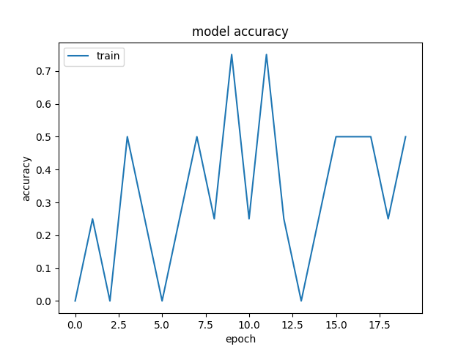

Figure 1
Baseline: Model Accuracy
The model accuracy chart exhibits a sawtooth pattern where there are large fluctuations in accuracy. There is a discrete step artifact where accuracy peaks and troughs at quarter values which could be due to the small training set. It is evident that the model is overshooting due to the large batch size and dense layer applied to a relatively small dataset.

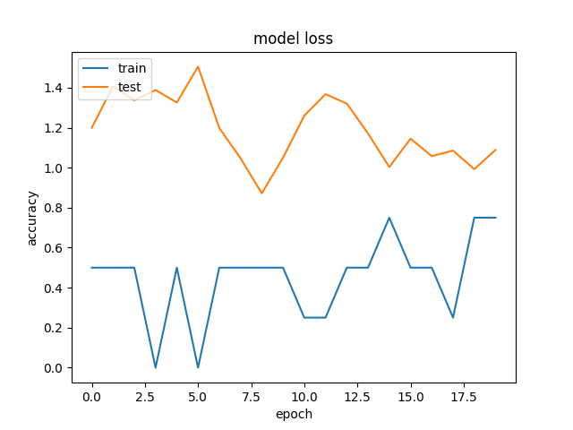

Figure 2
Baseline: Model Loss
It is evident that there is numerical instability during the training process signifying that our loss function is not suited for scale of inputs and lack of feature normalization. This could also signal that our prediction accuracy is not precise and cannot extract any meaningful relationships.

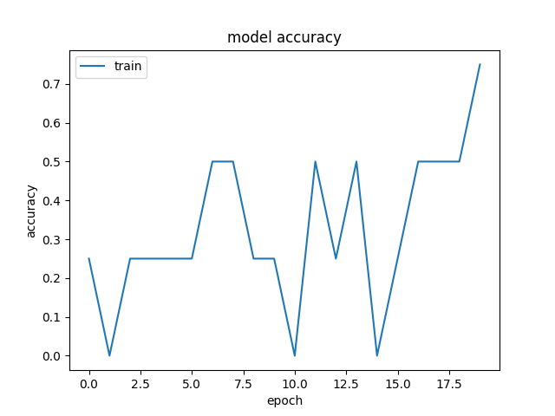
Figure 3
Experiment 1:Model Accuracy
It was discovered that dropout rate has a direct effect on accuracy level where a 30% dropout rate achieved an accuracy level of 70% at epoch 17.5 in the models Goldilocks Zone where the model has learned general data patterns without memorization. At a size of 179 active neurons within the hidden layer, the model successfully extracts intricate patterns from the data.

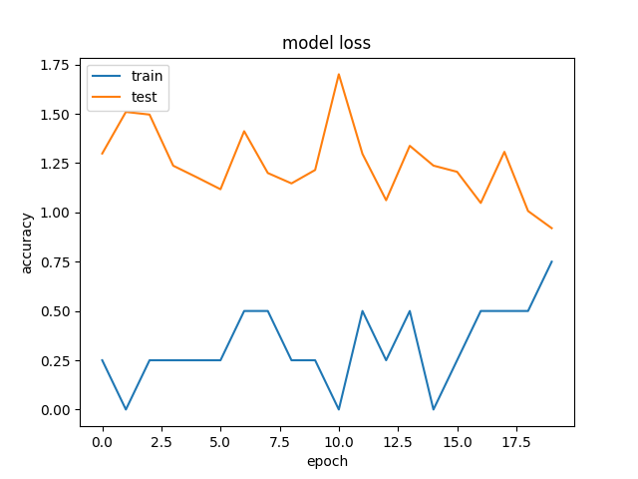

Figure 4
Experiment 1:Model Loss
The rigid shape of the training and test curves indicate that there is a potential conflict with learning rate and model capacity. There are approximately 77 neurons that inactivate for each batch run so weights and errors are drastically different.

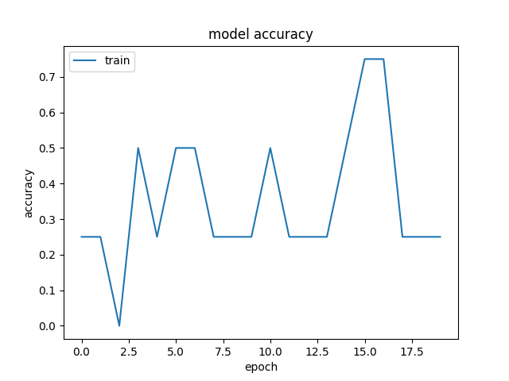
Figure 5
Experiment 2: Model Accuracy
As observed in the graph, the model plateaus as the model loses the ability to measure magnitude. Because of the binary quantization, the model can no longer learn through gradient descent which means it can no longer detect the strength of each magnitude of data. The plateaus could be a direct result of training on highly quantized data where it fails to adjust the data weight due to the binary feature rule where all features must be 0 or 1 so therefore accuracy remains flat until it surpasses the threshold hence accuracy has a large jump.

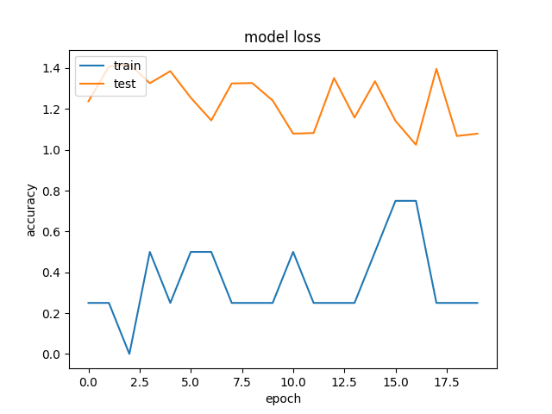

Figure 6
Experiment 2: Model Loss
The training line has a smooth shape with distinct spikes and plateaus. The training line seems to memorize four distinct patterns where the model's loss drops by 25%. The test line has a noticeable rigid shape with significant spikes and plateaus. At epoch 7, the weights adjust slightly but the predictions do not change unless all the weights are updated so therefore a plateau forms. At epoch 11, the weights shift enough to cross the threshold so therefore prediction shifts causing a sudden drop in accuracy.

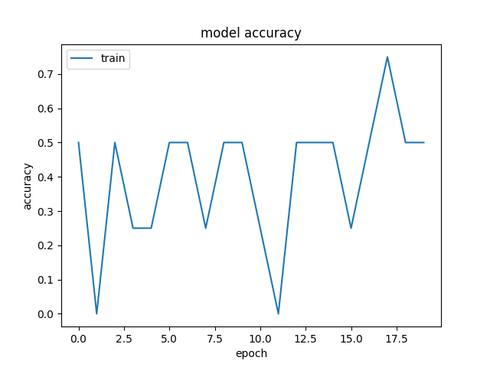

Figure 7
Experiment 3: Model Accuracy
The exponential linear unit has created a strong gradient as evident the accuracy has a smooth linear line that leads up to the plateau. The plateaus arise when the conflict between continuous learning and distinct grading where the model remains plateau until it surpasses the 50% threshold.

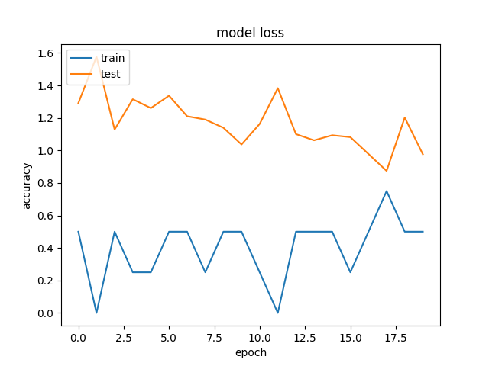
Figure 8
Experiment 3: Model Loss
It is evident that the exponential linear unit has a drastic effect on the training and test set. All positive input values follow a linear slope due to the gradient strength. The training line drops in the first epoch due to the lack of saturation therefore it automatically increases weight data input causing a 0% model loss. The testing line experiences noise dampening because the training data does not match with the testing data, it produces negative values as a result the exponential linear unit smoothes the values producing a jagged shape. This could signal a potential graph overfit where the model has memorized the training data causing a drastic shift in testing results.

Discussion
Machine learning model is a computational representation of advanced linear algebra applications. As with any mathematical function, it is highly dependent on inputs and its operational functions. This experimentation has given the team an opportunity not only to experiment with a sequential model computationally but gained a deep understanding of the model functionality mathematically as well.
As stated in the results, the hypothesis was disproven. The team discovered that there is not a significant difference in model accuracy between 2 data quantization levels and 4 data quantization levels respectively. This could be due to quantization noise modeling and flat minima geometry.
Figure 1
X_{q} = x + E

The signal to noise ratio (SNR) remains above the critical threshold value so therefore the signal is strong enough to remain detectable despite noise being introduced therefore a reduction in quantization from 4 to 2 does not corrupt the signal enough to corrupt the model decision making.
The Bernoulli track in experiment 1 is another interesting aspect that warrants exploration.Because of the Bernoulli trail effect, the model capacity begins to shrink. The computer begins generating a mask vector (M) where it performs an element-wise multiplication within each layer where a vector mask [1,0,1,0] is formed. Each neuron enters an active state 1 or inactive state 0 independent of the previous outcome. There is an average of 179 active neurons inserted into the dense hidden layer of the keras model in each batch run. Noise is introduced to the model because the number of active neurons fluctuate for each batch run causing the lines on the graph to be unstable. A future direction of this experimentation is to employ an exponential moving average which corresponds to the momentum in machine learning.

Figure 2
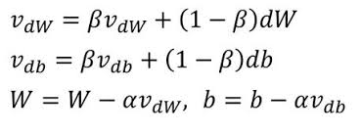
This concept could be implemented as an optimizer with momentum where the model updates weights based on batch averages which will correct the biased moving samples through a low pass filter effectively moving noise.

Conclusions
Over the course of a semester, the ProjectROI team has built a financial machine learning model that is used through an app interface. Our team has not only learned the applications of data science, linear algebra and finance but the importance of cross functional collaborations as well.
The purpose of this project is to contribute to wider conversation of financial illiteracy among young adults. People spend a quarter of their lifetime learning complex subjects such as math, science, language arts and social science but never took the time to learn how to handle wealth and make it work for their long-term benefit. Our team wanted to lessen the wealth gap for our clientele to make the transition into adulthood easier. As college graduates struggle to find jobs and young families cannot afford homes, there is a dire need for supplementary income to support people in the pursuit of happiness.
If this work were to be extended, our team would seek to transition the web application into a mobile app then release it to the Apple and Google app stores to make this widely accessible. Our team would also work to implement a more engaging and robust user interface where the user could dive deeper into machine learning rationale in stock picking, could select different themes and observe how their stock changed over time through a real time graphical interface of Yfinance data.

References
- [1] Yan, K., & Li, Y. (2024). Machine learning-based analysis of Volatility Quantitative Investment Strategies for American Financial Stocks. Quantitative Finance and Economics, 8(2), 364–386. https://doi.org/10.3934/qfe.2024014
- [2] Houweling, P., Messow, P., ‘T Hoen, R.-J., & Robeco. (2024). True Value Investing in Credits through Machine Learning. https://wp.lancs.ac.uk/fofi2024/files/2024/04/FoFI-2024-174-Robbert-Jan-t-Hoen.pdf
- [3] Cao, K., & You, H. (2022, September 28). Fundamental Analysis Via Machine Learning: Financial Analysts Journal: Vol 80, no 2. Taylor & Francis Online. https://www.tandfonline.com/doi/abs/10.1080/0015198X.2024.2313692
- [4] Artificial Neural Networks: Basic methods and applications in finance, management and decision making, a roadmap. (2021). [Journal-article]. Wings to the Research, 1–2. https://doi.org/10.31031/NRS.2021.06.000648

